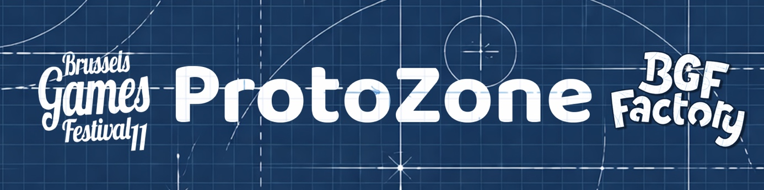

Brussels Games Festival 2026 – ProtoZone
  - Submission deadline: applications will be accepted until Sunday 31 May at 23:59.
  - The rules for participation in the ProtoZone are available at the end of this document.
  - Once this form has been completed, please send it by email to the following address: protozone@brusselsgamesfestival.be
  - Please ensure that all required elements are included (completed form, game rules, visuals and, where applicable, a file transfer link).
Submit your prototype

Game title

First name + last name of the author(s)

First name + last name of the illustrator(s)

Number of players

Min: Max:

Playing time (min–max OR time per player)
Please specify the playing time of your game (min–max or time per player).
Examples: 30–45 min; 60 min; 15 min/player

Age range of players
Please indicate the minimum recommended age to play the game.

Category

Children Families

Intermediate (Family+) Expert

Genre

Please specify the main genre of your game (e.g. party game, dice game, pirates, etc.).

Short game summary
Briefly summarise your game (maximum 200 characters)

Game description
Describe your game in more detail (maximum 1000 characters)

Submission of rules and visuals
Please include the following elements with your application:
• the game rules (PDF format preferred)
• one or more visuals of the prototype (photos, illustrations, screenshots, etc.)
Files can be sent directly as email attachments if their size allows it.
If the files are too large, you may use a file transfer service (such as SwissTransfer) and include the download link in your email.
Please name your files as follows to facilitate the processing of applications:
Game title – Author name – Rules
Game title – Author name – Visual

ProtoNight
If my prototype is not selected, I would like to take part in the “ProtoNight”, which will take place during the late opening on Saturday 29 August from 20:00
YES NO

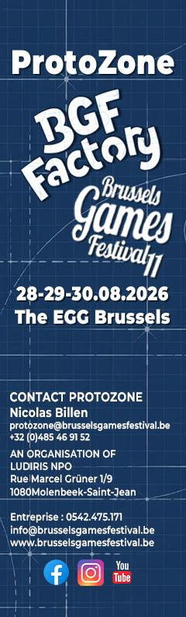
RULES – PROTOTYPE SUBMISSION

ProtoZone – Brussels Games Festival 2026
As part of the 11th edition of the Brussels Games Festival, a competition is organised for board game designers.
Selected prototypes will take part in the Meeple Pis d’Or competition, held within the ProtoZone of the BGF Factory during the 2026 edition of the festival.
HOW TO PARTICIPATE
The event is open to all game designers, regardless of nationality or age.
To participate, each applicant must submit a complete application including:
- the game sheet and general information, to be completed via the online form: <lien form 2026>
- the game rules in PDF format (see guidelines below)
- several photos of the game in play
- a photo of the author(s)
Each author may submit up to 4 different prototypes.
Only one prototype per person may be selected for the ProtoZone.

DEADLINES AND SELECTION
Submission deadline: Sunday 31 May 2026 at 23:59
Applications must be sent to: protozone@brusselsgamesfestival.be
The Brussels Games Festival preselection committee will review all applications.
Each participant will be informed of the result in early July, whether selected or not.
Selected authors must confirm their participation before 20 July 2026.
Without confirmation within this deadline, their spot may be offered to another applicant.

PROTOZONE DATES AND SCHEDULE
Selected authors commit to:
- being present on Friday 28, Saturday 29 and Sunday 30 August 2026
- ensuring a continuous presence at their stand during the following hours:
  - Friday 28 August: 14:00 to 20:00
  - Saturday 29 August: 11:00 to 19:00
  - Sunday 30 August: 11:00 to 18:00
Non-selected designers may still present their prototype during the ProtoNight, on Saturday 29 August from 20:00 to 03:00, by selecting the relevant option in the application form, subject to availability.

PARTICIPATION FEES
Participation in the ProtoZone is free of charge.
A paid catering option will be available for participants during the three days of the festival.
Detailed information, including content, pricing and payment terms, will be communicated in the participation confirmation email.
ELIGIBILITY CRITERIA
All board games, in the broad sense, are eligible provided that they:
- have not been published
- are not currently in production or under contract
The Brussels Games Festival reserves the right to refuse any game whose content or theme is considered inappropriate for a family-oriented public event.
SELECTION PROCESS
Prototypes are evaluated based on the following criteria:
- clarity and quality of the rules
- quality and consistency of the game mechanics
- overall coherence of the project
- originality of the concept
The rules must be submitted:
- in French, Dutch or English
- in PDF format (under 10 MB, not compressed)
To facilitate readability, it is recommended to include:
- a description of the game and its theme
- general information:
  - duration
  - number of players
  - recommended age
- a description of the components
- visual materials of the game (files named with the game title)
- the gameplay structure:
  - setup
  - phases of play
  - example if necessary
  - win conditions
  - any other relevant information
To facilitate the processing of applications, it is strongly recommended to name the files as follows:
- Game name – Author name – Rules
- Game name – Author name – Visuals

COMPETITION – PROTOZONE 2026
As part of ProtoZone 2026, selected prototypes will take part in a competition highlighting the creativity and quality of the presented games.
Two prizes will be awarded:
Meeple Pis d’Or
awarded by the public, recognising the prototype that made the strongest impression on visitors
Jury Prize
awarded by a panel of professionals from the games industry
Festival visitors will receive a voting ballot allowing them to select their favourite prototype among the games they have played.
The voting system rewards engagement: the more prototypes a visitor tests, the more weight their vote carries.
Public voting will close on Sunday 30 August at 13:00.
The award ceremony will take place on Sunday at 16:00.
The two winners of ProtoZone 2026 will be selected to take part in the Creators’ Village, organised by La Ruche Ludique during the 2027 edition of the FLIP in Parthenay.

